Eldon Area Chamber of Commerce

***24th Annual Eggs & Issues***

**March 14, 2025**

Eldon Community Center

7 - 8:45 a.m.

Please join us Friday, March 14, for the 24th Annual Eggs & Issues breakfast. Meet some of Missouri’s top elected officials and their representatives and hear about topics affecting you.

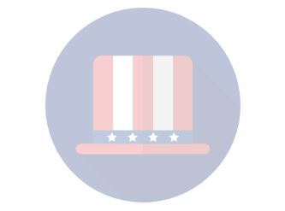

*Invited Guests*

**Governor Mike Kehoe**

**U.S. Senator Josh Hawley**

**U.S. Senator Eric Schmitt**

**U.S. Representative Dr. Bob Onder**

**State Senator Mike Bernskoetter**

**State Representative Willard Haley**

**State Representative Don Mayhew**

**Eldon Mayor Trevor Vernon**

**Miller County Presiding Commissioner Kevin Cardwell**

*Schedule of Events*

7 a.m. Buffet Breakfast

7:30-8:45 a.m. Program

Return your completed form and payment to the Eldon Area Chamber office at 210 E. 6th St. before March 6.

Business Name Contact Name

Contact Phone Contact Email

Yes, I look forward to attending March 14, 2024, Eggs & Issues breakfast!

Number Attending x $20 each = Total Due

***Payment must be received before March 6.*** Make checks payable to Eldon Area Chamber of Commerce.

Signature

***\*\*****I understand I will be billed for the total number of RSVP’s stated on this form even if I am unable to attend and do not cancel my reservation before March 6.* ***\*\****



Need additional information? Call 573-392-3752 or email mkostelnik@eldonchamber.com.